AI Home Guardian - The Smart Home of 2035
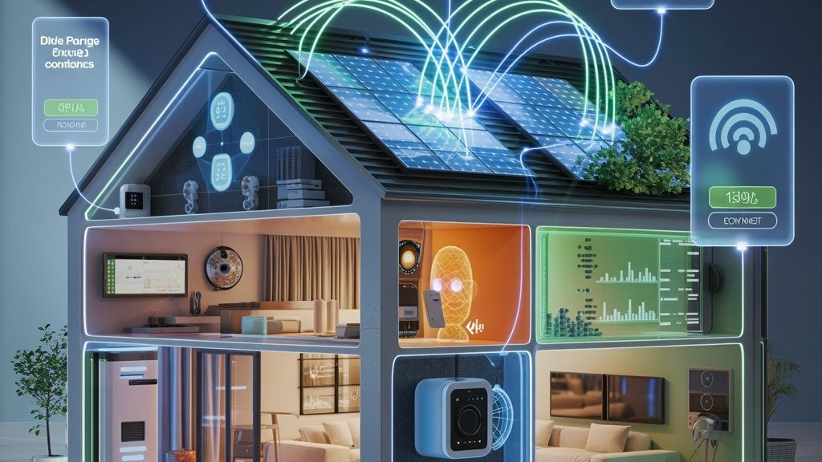
Artificial Intelligence (AI) is rapidly changing different areas of society. By 2035, AI could make homes more intelligent, automated, secure, and accessible. As an AI innovator in 2035, I propose an AI-powered smart-home system called “AI Home Guardian.” The system would combine Artificial Intelligence, Machine Learning, Internet of Things (IoT), computer vision, sensors, and natural language processing to create an intelligent home environment.
Unlike traditional smart homes that mainly respond to user commands, AI Home Guardian would learn from household routines and make appropriate decisions automatically.

1. Energy Management
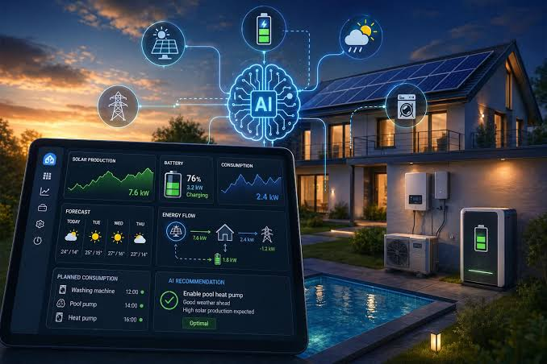
Energy management would be one of the main features. The AI would monitor electricity consumption from appliances, lighting, heating, cooling, and other devices. It could automatically switch off unused appliances and optimize air conditioning and lighting.
The system could also work with solar panels and home batteries. By analyzing energy production and consumption, AI could determine when appliances should operate to reduce unnecessary energy usage and support a more sustainable home.

2. Intelligent Security
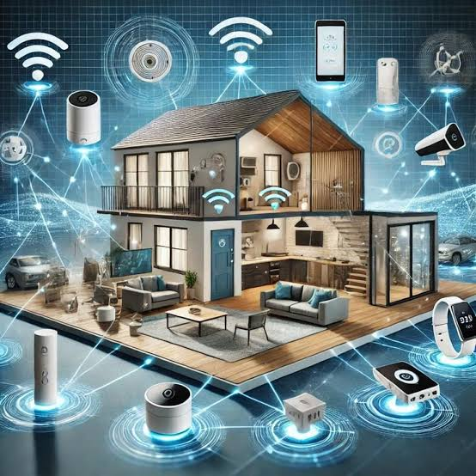
AI Home Guardian would provide intelligent security using cameras, motion sensors, smart locks, and other devices. Computer vision could help identify unusual activity, while sensors could detect unexpected movement around the property.
The system could notify authorized residents when unusual events occur. It could also detect hazards such as smoke, fire, gas leaks, water leaks, and abnormal environmental conditions, helping residents respond quickly.

3. Accessibility and Assistance
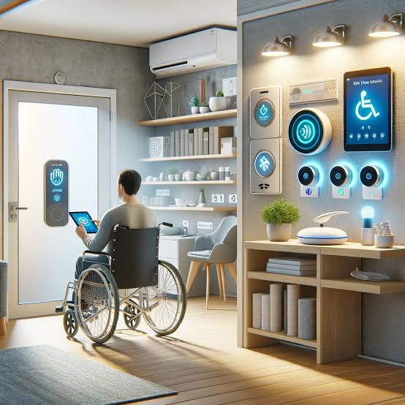
Accessibility would be an important part of the system. AI Home Guardian could support elderly people and people with disabilities by allowing them to control household devices through voice commands, simple interfaces, or automated actions.
For example, users could say “turn on the bedroom light” or “open the curtains.” Doors, lights, appliances, and other devices could also be automated according to individual needs. The system could provide reminders and notifications when necessary.

4. Comfort and Personalization
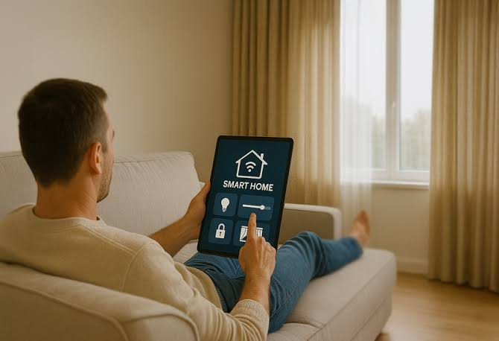
The system would learn residents' preferences and automatically adjust temperature, lighting, curtains, entertainment systems, and other appliances. For example, it could prepare the living environment before residents arrive home.
Different family members could have personalized settings while still maintaining control over shared household devices.

5. Health and Safety

AI Home Guardian could monitor environmental conditions such as temperature, humidity, air quality, smoke, and carbon monoxide. If dangerous conditions are detected, the system could immediately notify residents and activate appropriate safety procedures.

6. Privacy and Data Protection
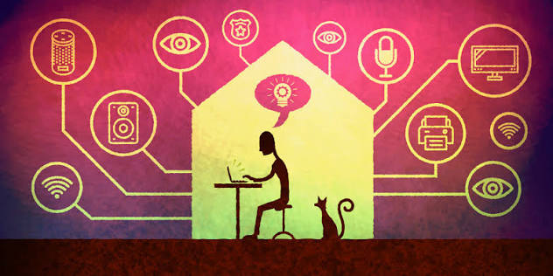
Because the system would process potentially sensitive household information, privacy and cybersecurity would be essential. Data should be encrypted, access should require secure authentication, and users should be able to control what information is collected and stored.

Conclusion
AI Home Guardian would transform a traditional house into an intelligent, secure, accessible, energy-efficient, and personalized living environment. By combining AI, IoT, automation, and smart sensors, the home of 2035 could support people's daily activities while improving safety, reducing energy consumption, and providing greater independence and convenience.

